***OOP LAB TASK # 12***

***Name: Shahmeer khan.***

***ClassID: 106278.***

***Student-ID:12113.***

***Task:***

***Question no. 1:***

***Inputted Code:***

using System;

using System.Collections.Generic;

using System.Linq;

using System.Text;

using System.Threading.Tasks;

namespace Lab_Task

{

class Program

{

static void Main(string[] args)

{

Console.WriteLine("OOP LAB TASK 12: ");

Console.WriteLine("Question no. 1:");

int i = 0;

Console.WriteLine("Press A to enter new book." + "\nPress any other key to exit the Program.");

string choice = Console.ReadLine();

if (choice == "a" || choice == "A")

{

do

{

Console.WriteLine("Enter book category below\n\nChemistry\tComputer\tMaths");

string cat = Console.ReadLine();

if (cat == "chemistry" || cat == "CHEMISTRY")

{

Console.WriteLine("Book Name =");

string a = Console.ReadLine();

Console.WriteLine("Author Name = ");

string b = Console.ReadLine();

Console.WriteLine("Price =");

double c = Convert.ToDouble(Console.ReadLine());

Chemistrybooks cheems = new Chemistrybooks();

cheems.Info(a, b, c, 0);

}

else if (cat == "computer" || cat == "COMPUTER")

{

Console.WriteLine("Book Name =");

string a = Console.ReadLine();

Console.WriteLine("Author Name = ");

string b = Console.ReadLine();

Console.WriteLine("Price =");

double c = Convert.ToDouble(Console.ReadLine());

Computerbooks comps = new Computerbooks();

comps.Info(a, b, c, 0);

}

else if (cat == "maths" || cat == "MATHS")

{

Console.WriteLine("Book Name =");

string a = Console.ReadLine();

Console.WriteLine("Author Name = ");

string b = Console.ReadLine();

Console.WriteLine("Price =");

double c = Convert.ToDouble(Console.ReadLine());

Mathbooks ehh = new Mathbooks();

ehh.Info(a, b, c, 0);

}

else

{

Console.WriteLine("Bye!");

}

} while (i < 5);

}

else

{

Console.WriteLine("Program Ended");

}

Console.ReadKey();

}

}

abstract class Book

{

public string name { get; set; }

public string author { get; set; }

public double price { get; set; }

public int qty { get; set; }

public abstract void Info(string name, string author, double price, int qty);

}

class Chemistrybooks : Book

{

public override void Info(string _Name, string _Author, double _Price, int _qty)

{

this.name = _Name;

this.author = _Author;

this.price = _Price;

this.qty = _qty;

Console.WriteLine("The name of the book: " + name + "\nThe name of the Author: " +

author + "\nThe Price: " + price + "The quantity available: " + qty);

}

}

class Computerbooks : Book

{

public override void Info(string _Name, string _Author, double _Price, int _qty)

{

this.name = _Name;

this.author = _Author;

this.price = _Price;

this.qty = _qty;

Console.WriteLine("OK");

}

}

class Mathbooks : Book

{

public override void Info(string _Name, string _Author, double _Price, int _qty)

{

this.name = _Name;

this.author = _Author;

this.price = _Price;

this.qty = _qty;

Console.WriteLine("Maths! Seriously ?\nWell, the information you entered has been stored.");

}

}

}

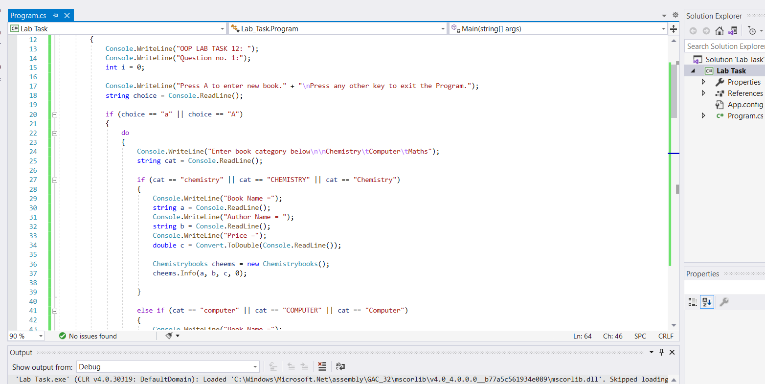

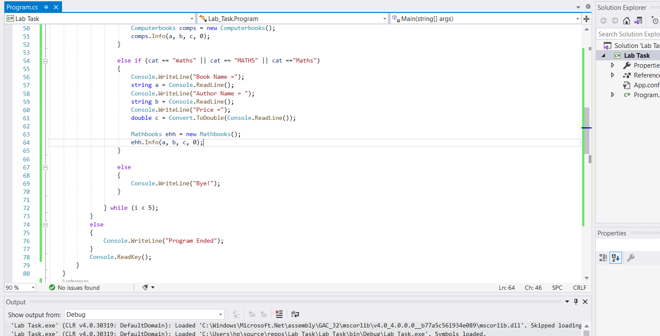

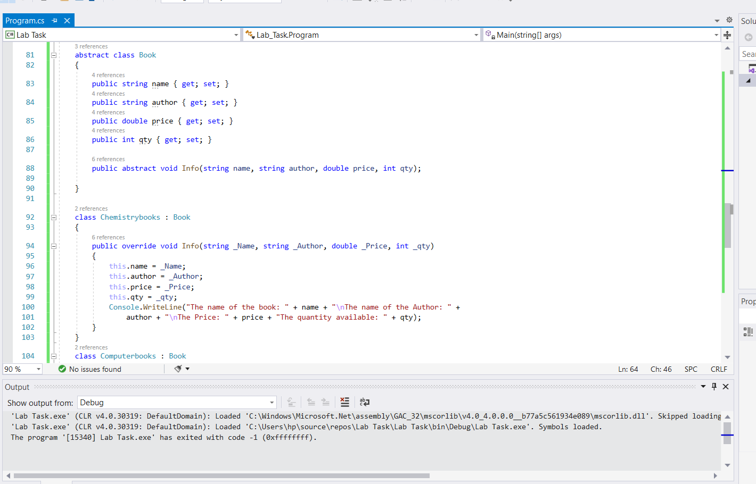

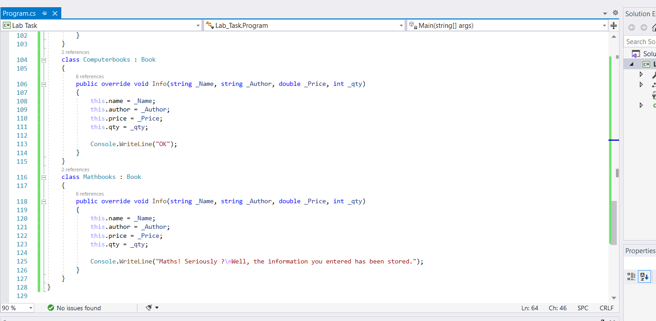

***Output:***

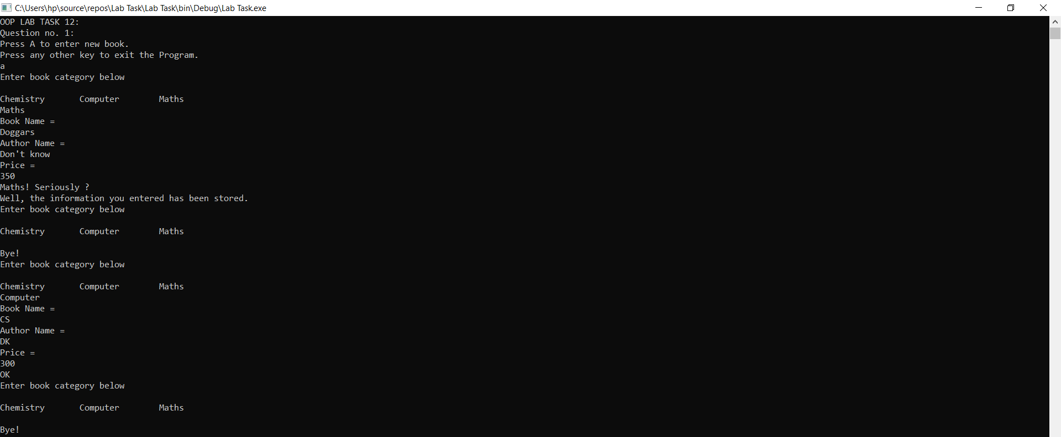

***Question no. 2:***

***Inputted Code:***

using System;

using System.Collections.Generic;

using System.Linq;

using System.Text;

using System.Threading.Tasks;

namespace Lab_Task

{

class Program

{

static void Main(string[] args)

{

Boat b = new Boat();

b.ModeOfTravel();

Car c = new Car();

c.ModeOfTravel();

Airplane a = new Airplane();

a.ModeOfTravel();

Console.ReadKey();

}

}

public abstract class Travelmode

{

public abstract void ModeOfTravel();

}

class Boat : Travelmode

{

public override void ModeOfTravel()

{

Console.WriteLine("Sea");

}

}

class Car : Travelmode

{

public override void ModeOfTravel()

{

Console.WriteLine("Earth");

}

}

class Airplane : Travelmode

{

public override void ModeOfTravel()

{

Console.WriteLine("Sky");

}

}

}

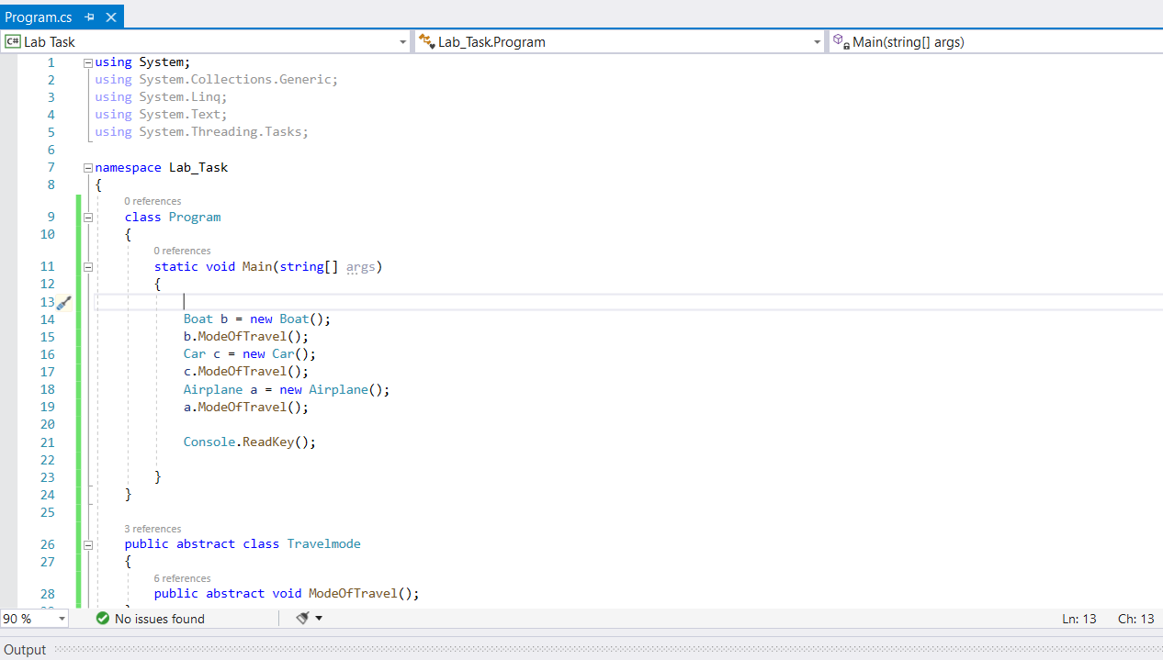

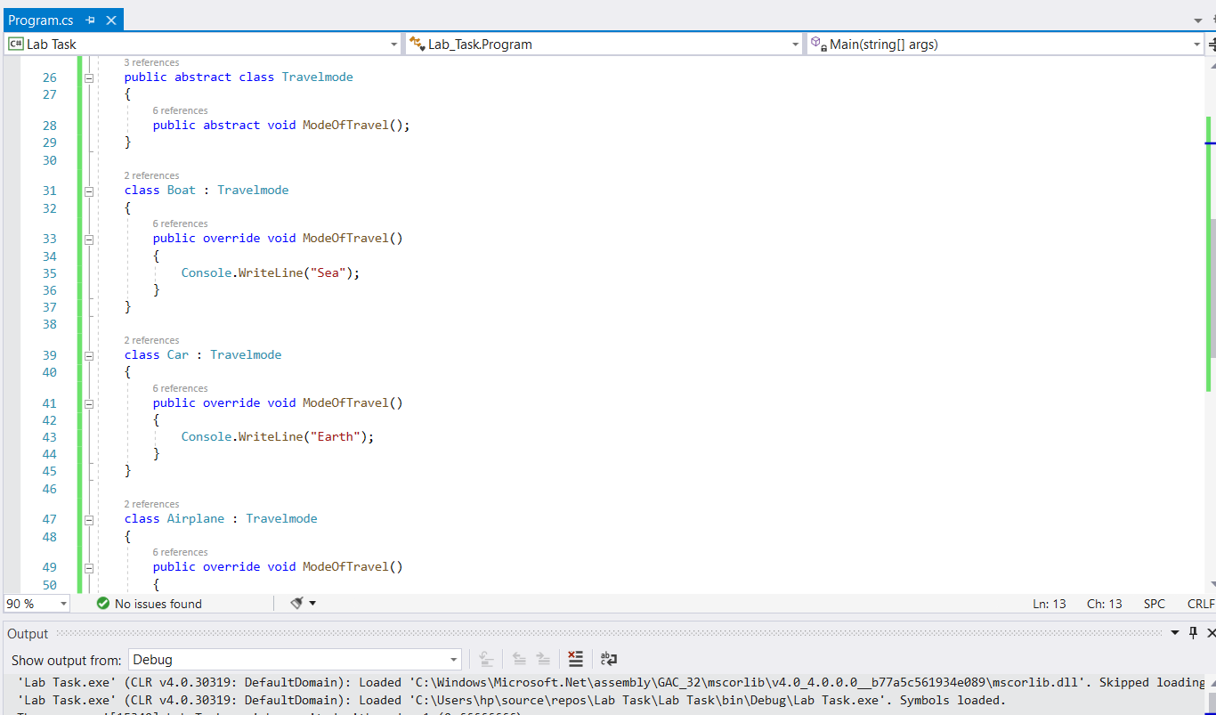

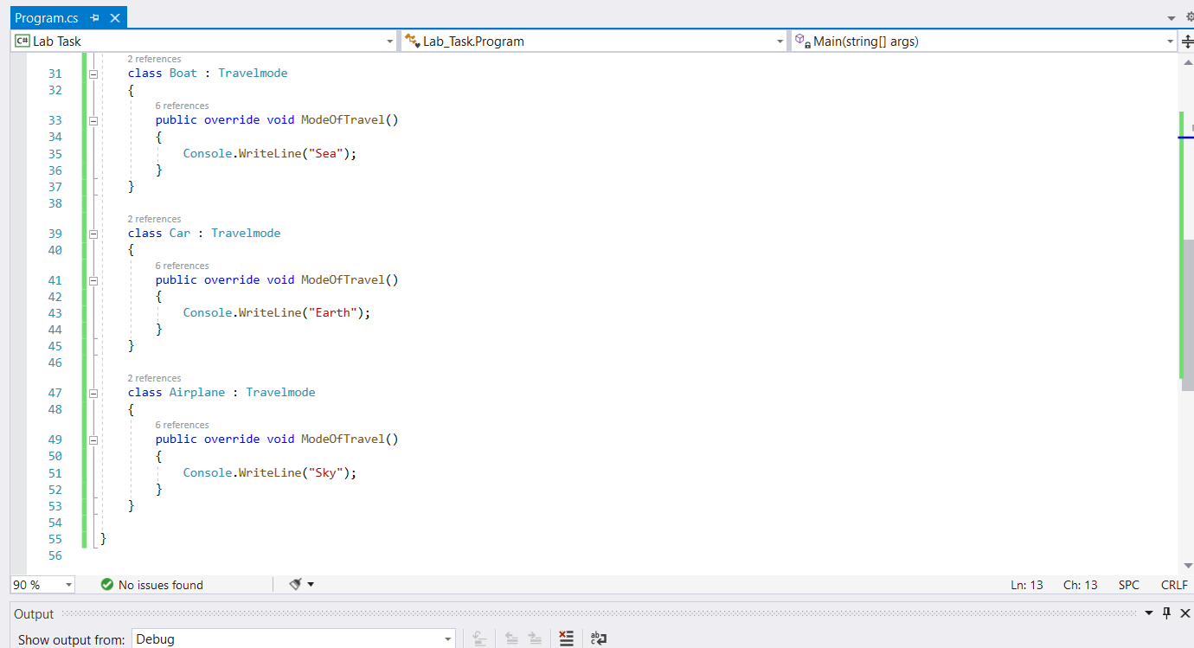

***Output:***

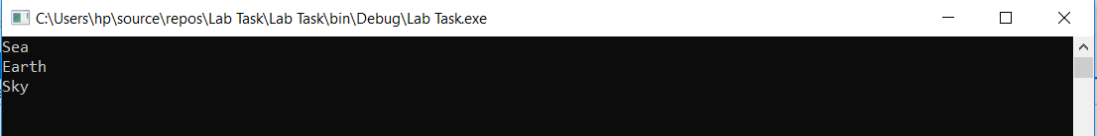

***Question no. 3:***

***Inputted Code:***

using System;

using System.Collections.Generic;

using System.Linq;

using System.Text;

using System.Threading.Tasks;

namespace Lab_Task

{

class Program

{

static void Main(string[] args)

{

Console.WriteLine("OOP LAB TASK 12: ");

Console.WriteLine("Question no. 3:");

Console.WriteLine("Press A to stop by for refuelling"

+ "\nPress any other key to check available modes of Travel");

string a = Console.ReadLine();

Boat b = new Boat();

if (a == "a" || a == "A")

{

b.Refuel();

Console.WriteLine("Ready to go");

}

else

{

Airplane ap = new Airplane();

ap.ModeOfTravel();

Car c = new Car();

c.ModeOfTravel();

//Boat b = new Boat();

b.ModeOfTravel();

}

//b.Refuel();

Console.ReadKey();

}

}

public abstract class Travelmode

{

public abstract string ModeOfTravel();

public string Refuel()

{

string refuel = "refuel complete!";

Console.WriteLine("Refuelling! Please wait....\n...\n" + refuel);

return refuel;

}

}

class Boat : Travelmode

{

public override string ModeOfTravel()

{

string medium = "Water";

Console.WriteLine("Travelling by Water");

return medium;

}

}

class Car : Travelmode

{

public override string ModeOfTravel()

{

string medium = "Land";

Console.WriteLine("Travelling by Land");

return medium;

}

}

class Airplane : Travelmode

{

public override string ModeOfTravel()

{

string medium = "Air";

Console.WriteLine("Travelling by Air");

return medium;

}

}

}

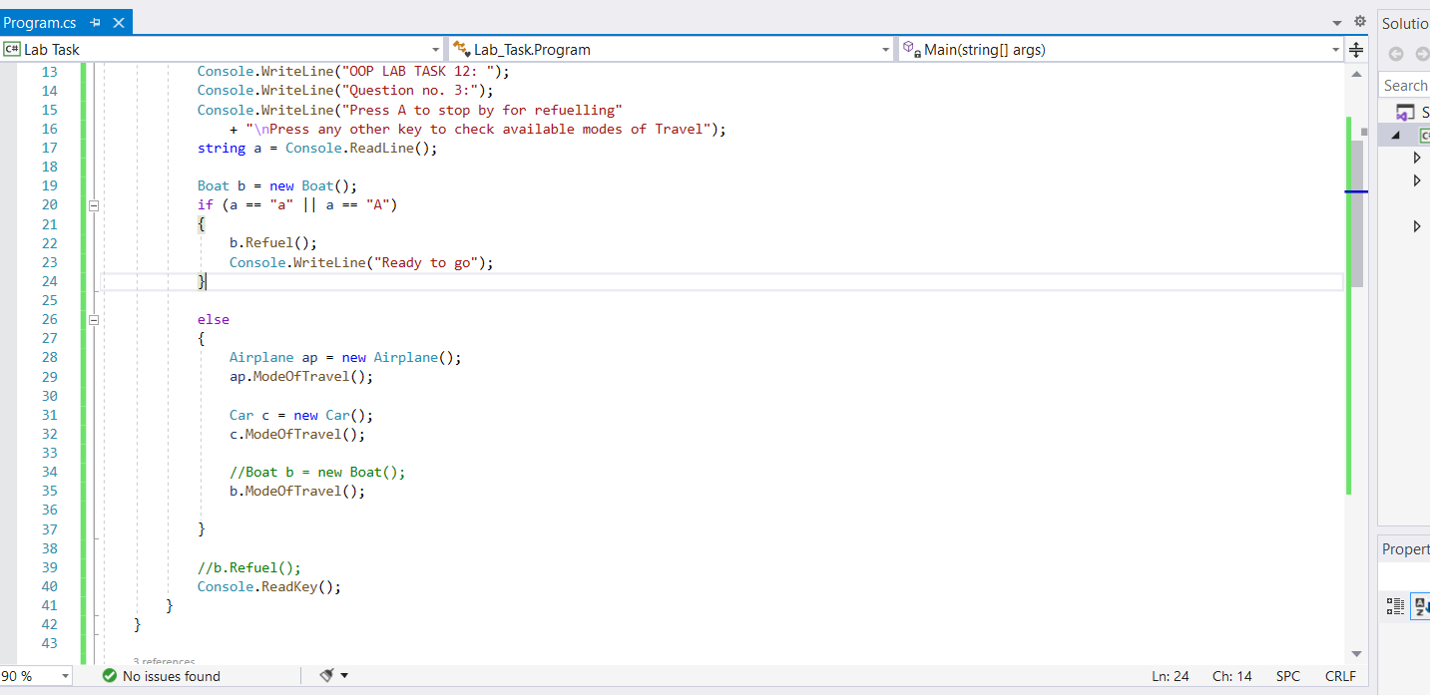

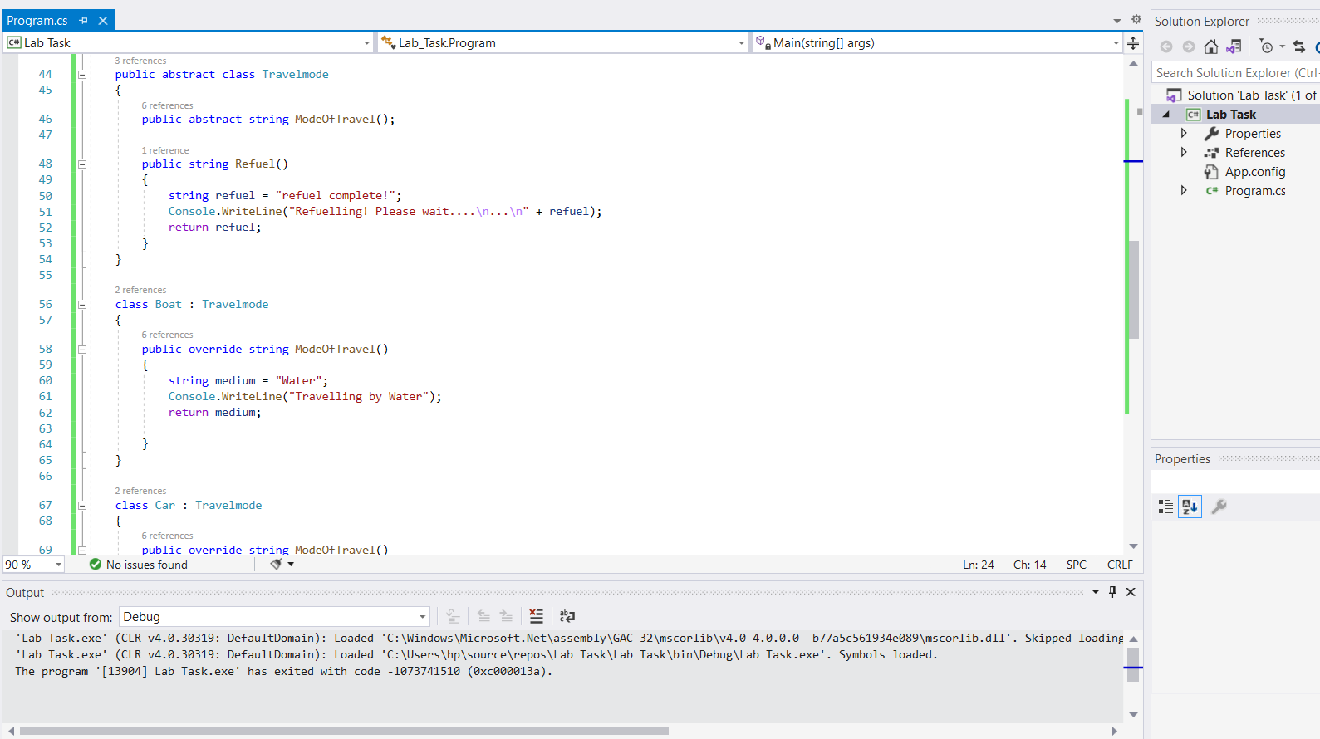

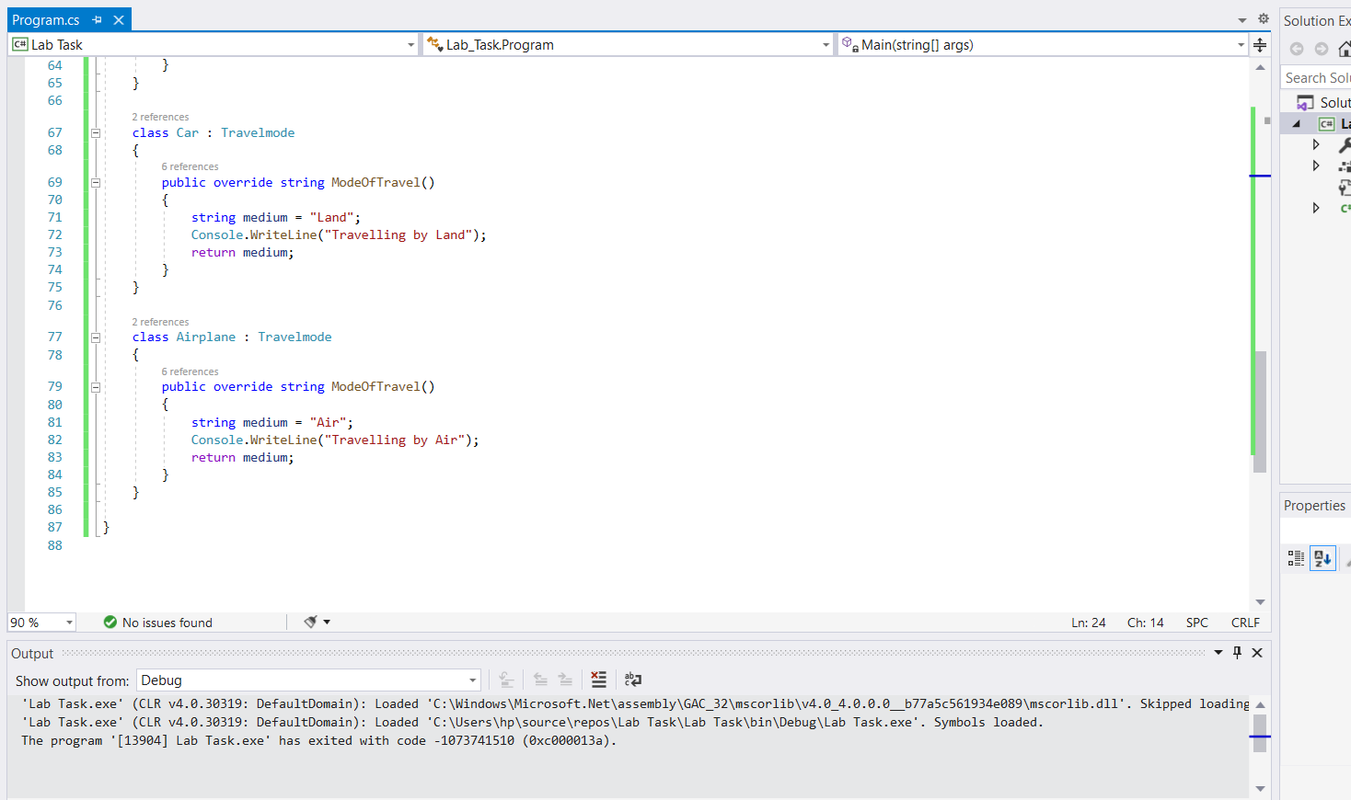

***Output:***

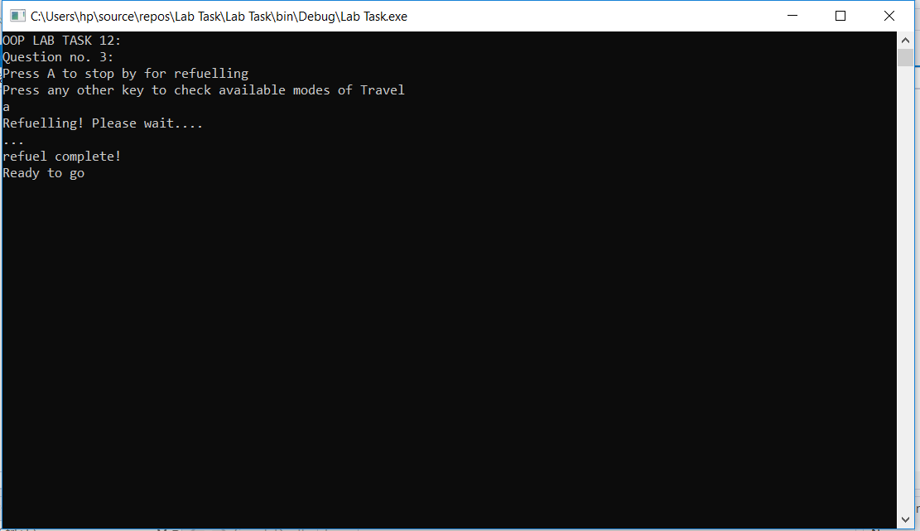

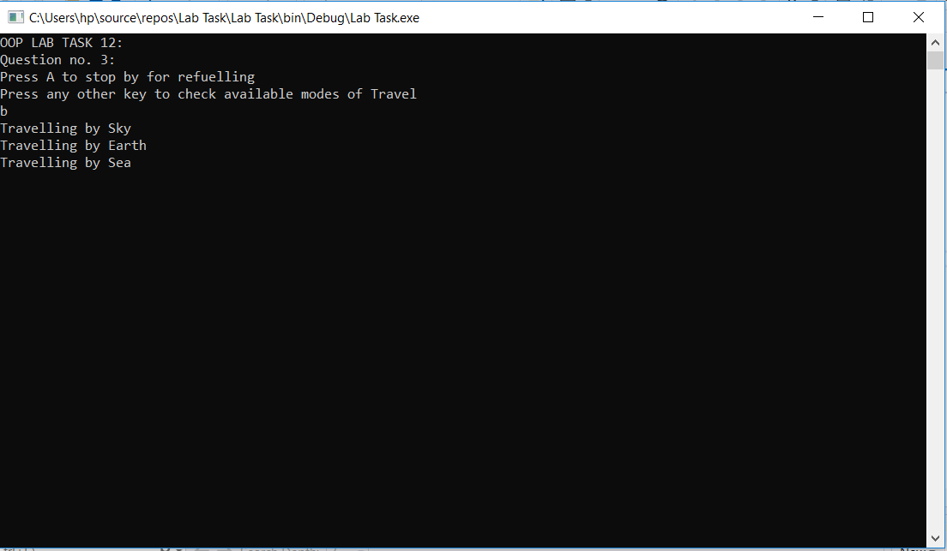

***Question no. 4:***

***Inputted Code:***

using System;

using System.Collections.Generic;

using System.Linq;

using System.Text;

using System.Threading.Tasks;

namespace Lab_Task

{

class Program

{

static void Main(string[] args)

{

Console.WriteLine("OOP LAB TASK 12:");

Console.WriteLine("Question no. 4:");

//Console.WriteLine("Press A to stop by for refuelling"

// +"\nPress any other key to check available modes of Travel");

//string a = Console.ReadLine();

Professor proof = new Professor("Mr Anakin Skywalker", "Luke CageWalker", 12500000.25);

proof.firstName();

proof.lastName();

proof.salary();

Console.ReadKey();

}

}

interface Person

{

string firstName();

string lastName();

}

class Professor : Person

{

string _firstname;

string _lastname;

double Salary;

public Professor(string _fname, string _lname, double _salary)

{

_firstname = _fname;

_lastname = _lname;

Salary = _salary;

}

public string firstName()

{

Console.WriteLine("Professor First Name = " + _firstname);

return _firstname;

}

public string lastName()

{

Console.WriteLine("Professor Last Name = " + _lastname);

return _lastname;

}

public double salary()

{

Console.WriteLine("The Professor's Salary = " + Salary);

return Salary;

}

}

class Student : Person

{

string _firstname;

string _lastname;

string Major;

public Student(string _fname, string _lname, string _major)

{

_firstname = _fname;

_lastname = _lname;

Major = _major;

}

public string firstName()

{

Console.WriteLine("Student First Name = " + _firstname);

return _firstname;

}

public string lastName()

{

Console.WriteLine("Student Last Name = " + _lastname);

return _lastname;

}

public string major()

{

Console.WriteLine("The Student's Major = " + Major);

return Major;

}

}

}

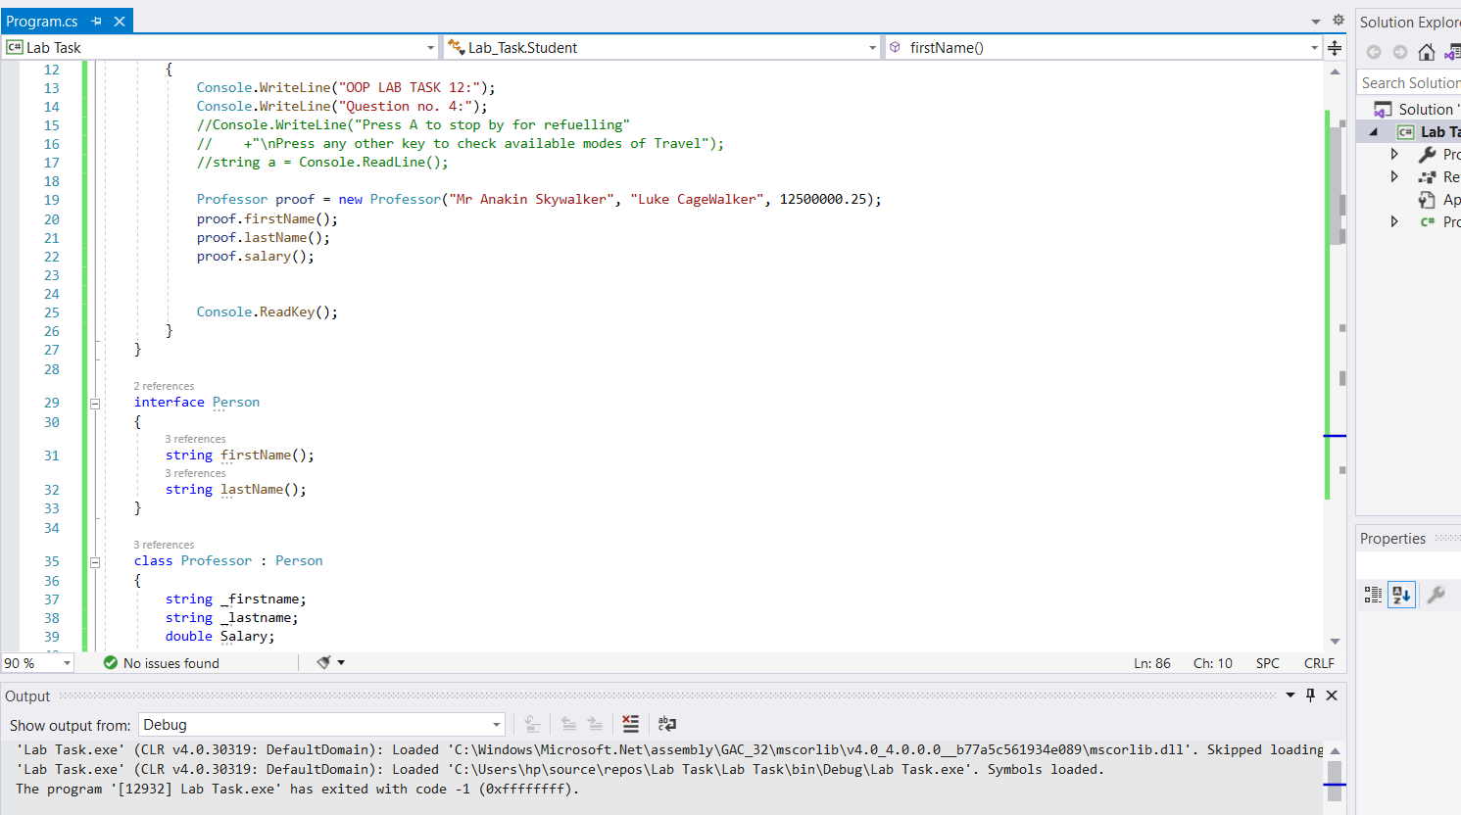

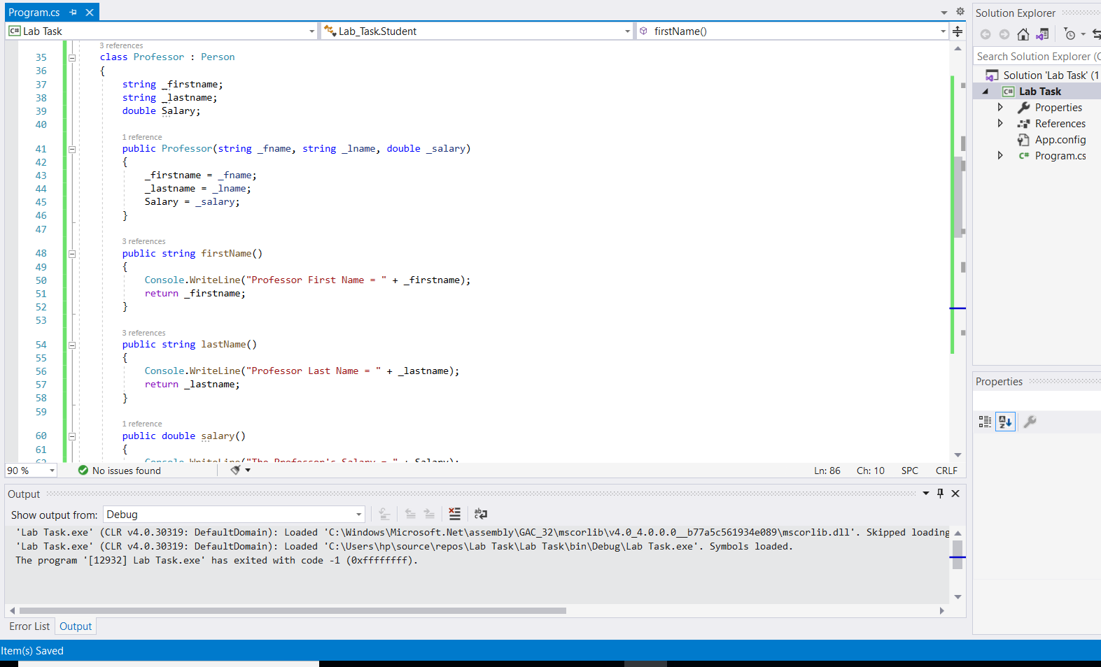

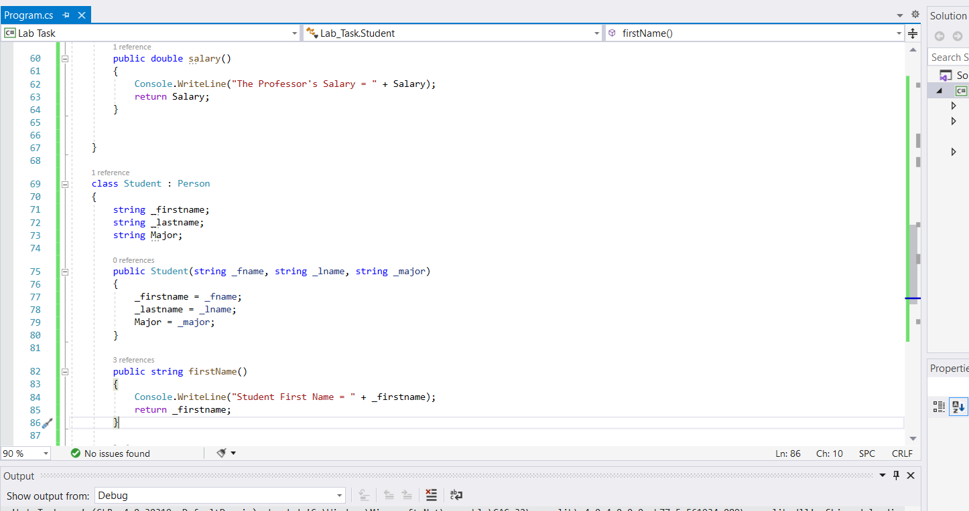

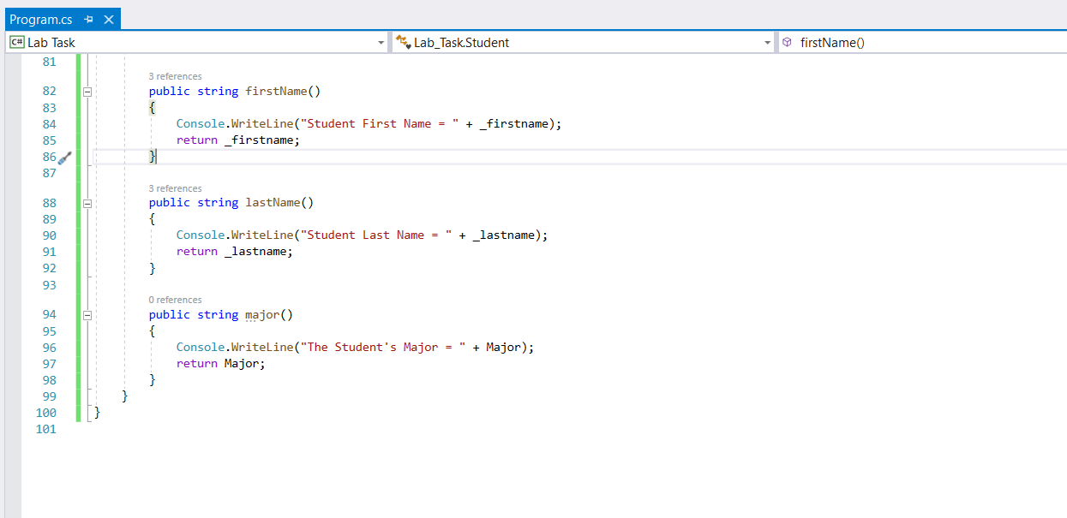

***Output:***

